

Sustainable Development – Zagreb County’s Policy for Destination Management, Conservation and Protection of Nature, the Environment, Culture and Society, and the Improvement of Tourism

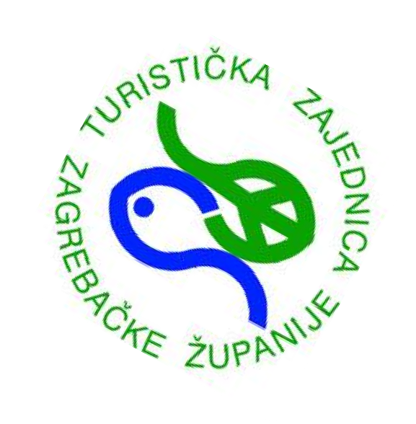
A DESTINATION TAILORED TO PEOPLE

VISIT ZAGREB COUNTY
SUSTAINABLE DEVELOPMENT


ACHIEVING SUSTAINABILITY THROUGH CERTIFICATION

These certifications represent leading standards of excellence in sustainable business practices within the tourism sector. They focus on the commitment of tourism enterprises to environmentally responsible management, social responsibility, and health and safety. Their cost is affordable and accessible to small and medium-sized enterprises, typically up to several hundred euros per year, with additional audit-related costs.
Good Travel Seal by Green Destinations Green Globe
Green Key
Although these certifications are primarily tailored to the needs of small and medium-sized enterprises, large companies can also be certified. Certification is available to all types of businesses across the tourism value chain, including hotels, hostels, campsites, private accommodation providers, bars, restaurants, destination activity providers, car rental services, and others.

Tourism Lab d.o.o. Službeni predstavnik Green
Destinations

APPLICATION PROCESS
1

 GOOD TRAVEL SEAL BY GREEN DESTINATIONS
The online application, which includes the submission of a report and supporting documents, is assessed by a team of experts who evaluate how many of the required criteria the business has met. If a facility meets at least 50% of the 57 general criteria (plus additional sector-specific criteria), it will be awarded the certificate and receive payment information. Following this, an annual audit is conducted by an independent auditor, either online (via video call) or on-site.

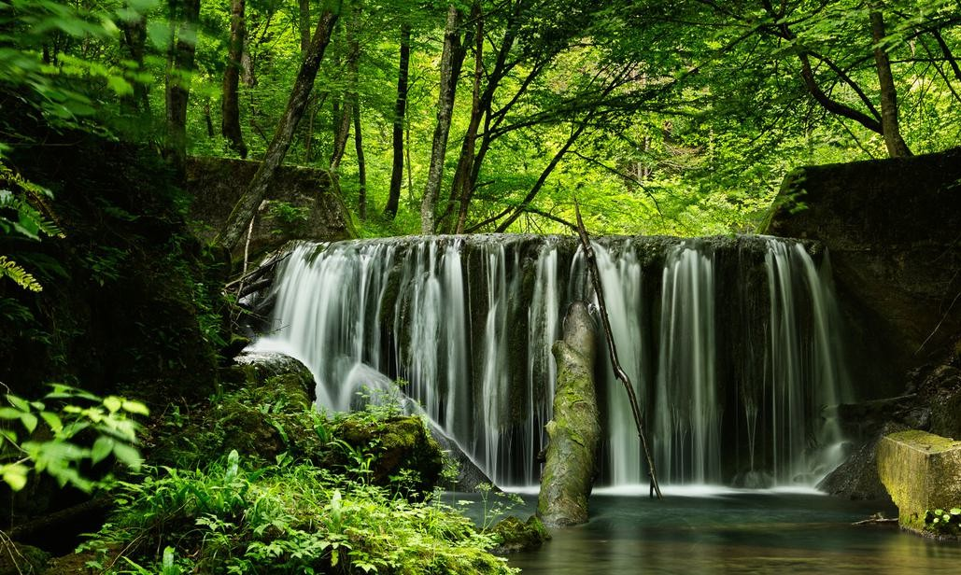
 GREEN GLOBE
GREEN KEY
Green Key is an award, unlike the two certification programmes mentioned above. Green Key promotes a promise to guests that by choosing to stay at a Green Key–certified facility, they are personally helping to make a positive difference in environmental protection. Once approved, the awarded facility receives a plaque with a sticker and a certificate. The Green Key award is valid for 12 months and must be renewed annually. On-site audits are conducted every three years.
The Green Globe certificate includes 44 core criteria supported by more than 380 indicators. After completing online registration and submitting all required information, the application will be evaluated. Once the Green Globe certificate is obtained, independent mandatory on-site and online audits must be completed every two years, and certification is granted when more than 50% of the criteria are met.

*Izvor: TrendFlow by thinktourism (2021).


2

SUSTAINABLE TOURISM

HOW TO DEFINE SUSTAINABILITY

There are more than 100 definitions of sustainability and sustainable development. According to the definition of the World Commission on Environment and Development, “development is sustainable when it meets the needs of the present without compromising the ability of future generations to meet their own needs.” There are three pillars of sustainable development: economic prosperity, environmental protection and quality, and social justice and equity.

 TRENDS IN SUSTAINABLE TOURISM
Reduction in air travel and an increase in train travel
• Growing demand for sustainable accommodation across all categories
• Longer and slower journeys combined with authentic experiences and greater interaction with the local community
• Consumption of local products and increased demand for so-called “pro-nature” menus, which imply less meat and dairy products
• Vegetarian and vegan food offerings and other related products
• Travel outside peak seasons
• Travel to nearby, less popular and less-visited tourist destinations

Danas većina vlada, međunarodnih razvojnih agencija, trgovačkih udruženja, akademskih institucija i nevladinih organizacija prepoznaje i prihvaća da bez održivosti ne može postojati razvoj koji stvara dobrobit za sve dionike u destinacijskom lancu vrijednosti. Upravljanje okolišem i održivim razvojem treba riješiti ozbiljne probleme kao što je ekstremno siromaštvo te očuvanje dragocjene prirodne i umjetno stvorene resurse osnove na kojima se temelji prosperitet destinacije. Kako je sve veća potražnja za ekološki prihvatljivim proizvodima i uslugama široko prepoznata, mnogi dionici u turizmu nastoje implementirati ekološki prihvatljive prakse u svoje poslovanje kako bi osigurali konkurentsku prednost i privukli željene ciljne skupine.

Sustainability certification supports the implementation of environmentally friendly practices and helps businesses stand out from the competition, especially as sustainability becomes an increasingly important factor for travellers. When issued by an independent organisation, a sustainability certificate confirms a commitment to environmentally and socially responsible business practices. More information can be found through three well-known tourism certifications: Good Travel Seal by Green Destinations, Green Globe, and Green Key.

