
 ZERO FOOD WASTE 

PROTECT THE ENVIRONMENT AND CLIMATE
REDUCE WASTE, DON'T THROW
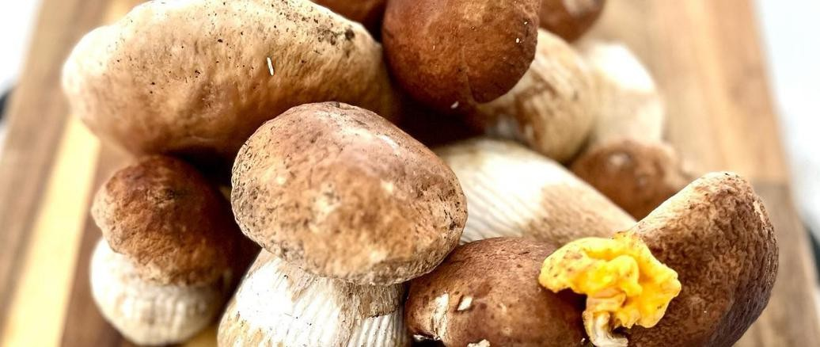
#VISITZAGREBCOUNTY

REDUCE FOOD WASTE, COOK FOR YOUR GUESTS!

TAKE ACTION!
TIRED OF THROWING FOOD AWAY? FOOD WASTE HAS ENVIRONMENTAL AND FINANCIAL CONSEQUENCES!

Enjoy your meal and take only as much as you can eat to avoid food waste.

By preventing food waste in hotels, we conserve resources, reduce landfill waste, and help make the environment an even more beautiful and pleasant place to return to.
Before going on holiday, check whether the hotels you choose participate in a food-waste reduction program.

 Dear Guests,
Caring for the environment and practicing sustainable tourism is nothing new: you yourselves surely support our hoteliers’ ecological efforts through small but important steps such as saving energy and drinking water, or helping prevent pollution by reusing hotel towels responsibly. But have you ever wondered about the food you enjoy every day? It’s hard for all of us to resist the tempting look and aroma of a hotel buffet, but we should remember that every time we return a plate with uneaten food, we also waste all the resources that were required to prepare that meal.
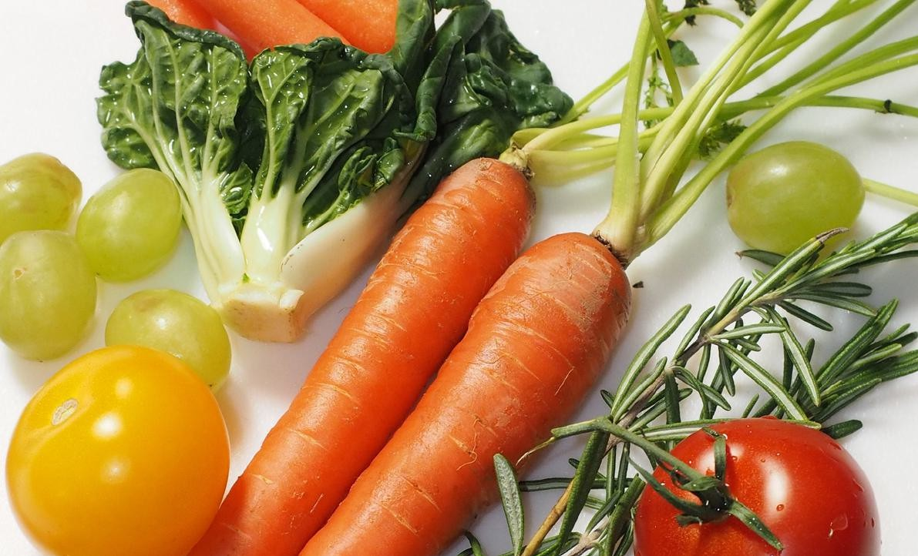
- Waste of energy and natural resources

FOOD WASTE
HAS ENVIRONMENTAL AND
FINANCIAL CONSEQUENCES!

- Environmental pollution
- Unnecessary cost

BE PART OF
THE SOLUTION

When ordering meals in the hotel restaurant, choose portions you can realistically finish.
If you notice that the restaurant serves large portions, feel free to ask for a smaller one or share a dish with someone when possible.
If you have leftovers from your meal, ask the hotel staff to pack them for you so you can enjoy them later.

Choose hotels that actively work on reducing food waste and apply sustainable practices in preparing and serving food.

Share what you know about reducing food waste with other hotel guests to help raise awareness about this important topic.

Hotels around the world that have implemented food-waste prevention strategies have reduced their waste by about 30%.

