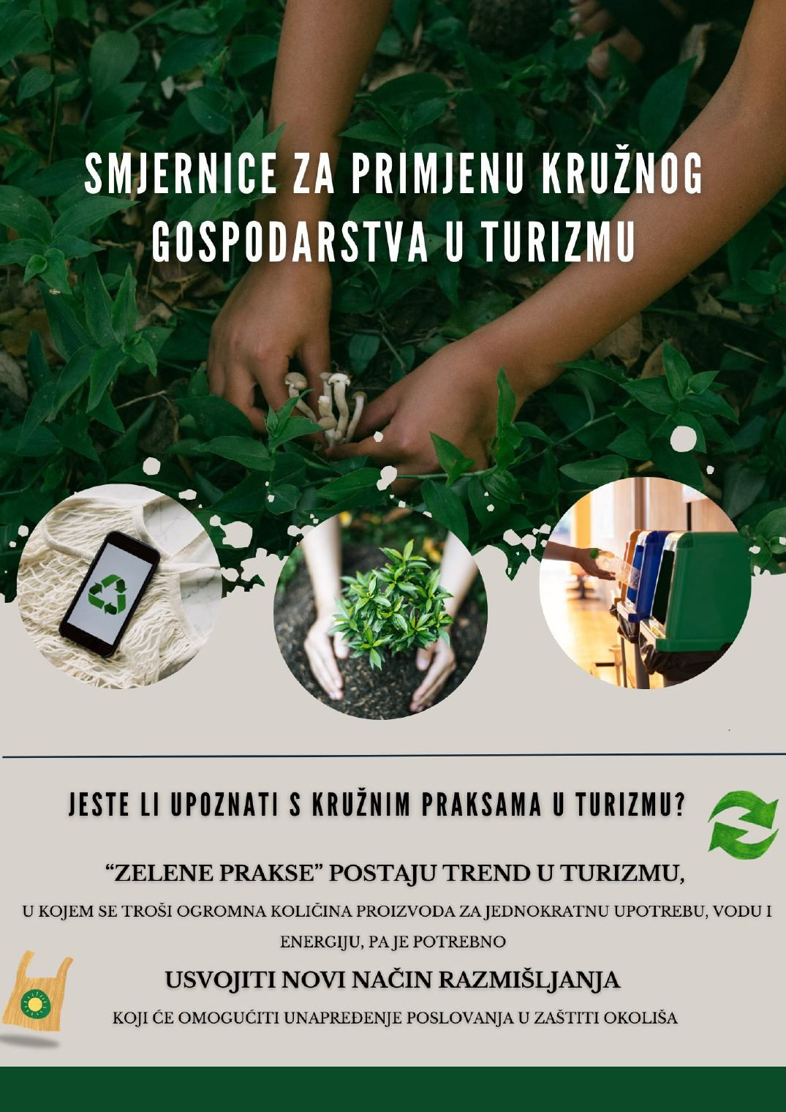

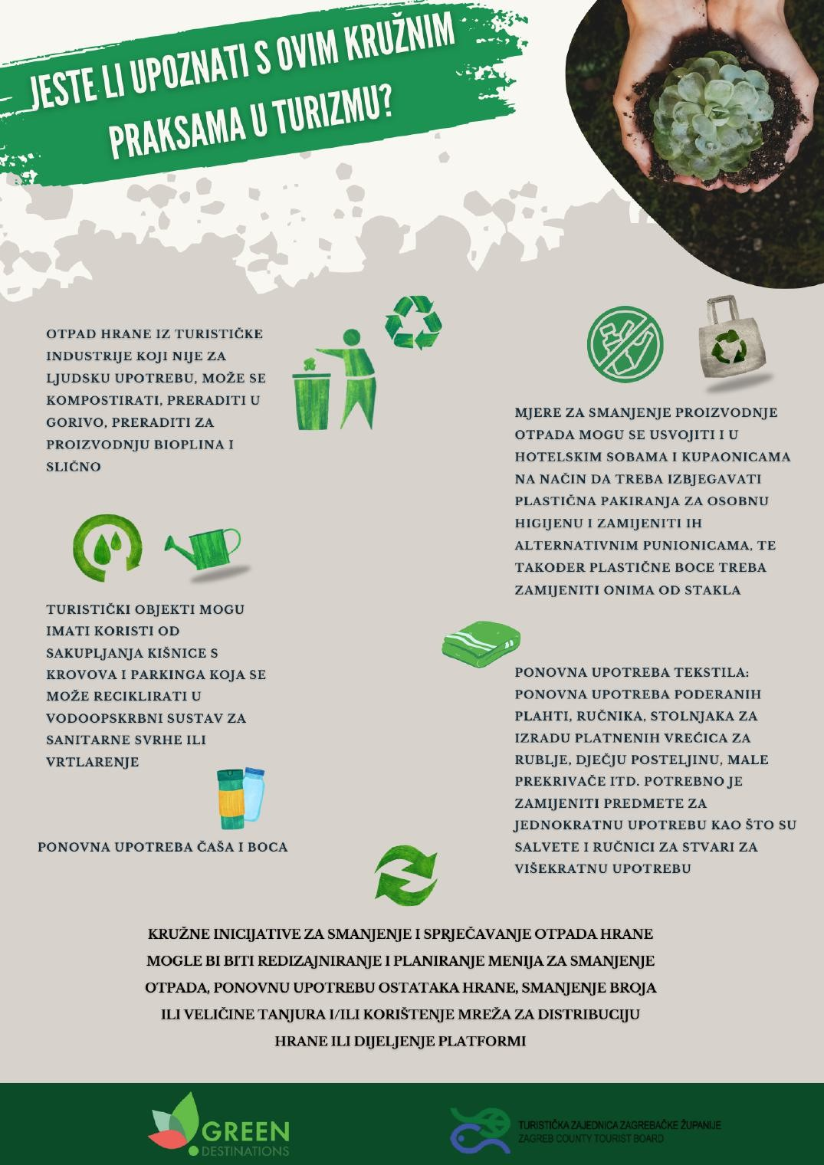

GUIDELINES FOR THE APPLICATION OF THE CIRCULAR ECONOMY IN TOURISM
Source

Are you familiar with circular practices in tourism?
“Green practices” are becoming a trend in tourism, where large quantities of single-use products, water, and energy are consumed, so it is necessary to adopt a new way of thinking that enables business improvement while protecting the environment.

Are you familiar with these circular practices in tourism?
Food waste from the tourism industry that is not suitable for human consumption can be composted, processed into fuel, processed for biogas production, and similar.

Tourism facilities can benefit from collecting rainwater from roofs and parking areas, which can be recycled into the water supply system for sanitary purposes or gardening.

Reuse of glasses and bottles

Measures to reduce waste generation can also be adopted in hotel rooms and bathrooms by avoiding plastic packaging for personal hygiene and replacing it with alternative refill systems, and plastic bottles should also be replaced with glass ones.

Reuse of textiles: reuse of torn sheets, towels, and tablecloths to produce laundry bags, children’s bedding, small blankets, etc. It is necessary to replace single-use items such as napkins and towels with reusable items.

Circular initiatives to reduce and prevent food waste could include redesigning and planning menus to reduce waste, reusing food leftovers, reducing the number or size of plates, and/or using food distribution networks or sharing platforms.

