

Guidelines for Appropriate Behaviour in the Destination, at Events and in Sensitive Areas –

a Guide to Visitor Management and Destination Pressure
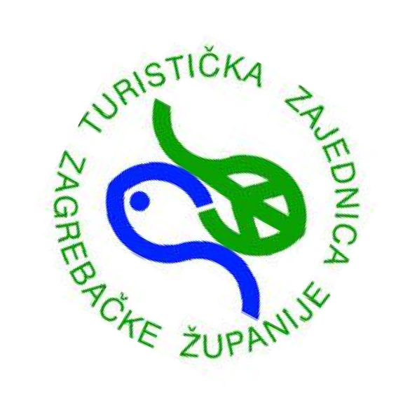

VISIT ZAGREB COUNTY
GUIDELINES FOR VISTIORS
A DESTINATION TAILORED TO PEOPLE

VISITOR BEHAVIOUR GUILDELINES FOR MUSEUMS AND OTHER SITES

The Zagreb County Tourist Board promotes sustainable and responsible behaviour toward nature, as well as toward all cultural and historical heritage sites located in Zagreb County.
To ensure a pleasant, safe, and respectful visit for everyone, visitors are kindly asked to follow these guidelines:

- touching exhibits is prohibited
- camping, setting up camps, and lighting fires are prohibited
- littering, including cigarette butts, is strictly prohibited
- damaging equipment or facilities at the site is prohibited
- respect local customs, traditions, and the local community
- polluting air, soil, or water is prohibited
- when entering churches, visitors must remain quiet and avoid disturbing others
- mobile devices must be switched off and loud conversations are not permitted
- appropriate clothing is required (shoulders and legs must be covered)

- consumption of food and drinks is not allowed in museum or visitor centre exhibition areas
- smoking is prohibited
- photography and filming are permitted only with staff approval
- pets are not allowed in museums or visitor centres
- allow others to enjoy the visit without disturbance
- sites that require admission tickets may not be entered without a valid ticket
- parking outside designated parking areas is prohibited
- visitors must follow designated routes and remain within marked paths

